Exp. No. 1
Develop a lexical Analyzer to identify identifiers, constants, operators using C
program.
AIM: To Develop a lexical Analyzer to identify identifiers, constants, operators using C
program.

Program:
#include<stdio.h>
#include<ctype.h>
#include<string.h>
int main()
{
int i,ic=0,m,cc=0,oc=0,j;
char b[30],operators[30],identifiers[30],constants[30];
printf("enter the string : ");
scanf("%[^\n]s",&b);
for(i=0;i<strlen(b);i++)
{
if(isspace(b[i]))
{
continue;
}
else if(isalpha(b[i]))
{
identifiers[ic] =b[i];
ic++;
}
else if(isdigit(b[i]))
{
m=(b[i]-'0');
i=i+1;
while(isdigit(b[i]))
{
m=m*10 + (b[i]-'0');
i++;
}
i=i-1;
constants[cc]=m;
cc++;
}
else
{
if(b[i]=='*')
{
operators[oc]='*';
oc++;
}
else if(b[i]=='-')
{
operators[oc]='-';
oc++;
}
else if(b[i]=='+')
{
operators[oc]='+';
oc++;
}
else if(b[i]=='=')
{
operators[oc]='=';
oc++;
}
}
}
printf(" identifiers : ");
for(j=0;j<ic;j++)
{
printf("%c ",identifiers[j]);
}
printf("\n constants : ");
for(j=0;j<cc;j++)
{
printf("%d ",constants[j]);
}
printf("\n operators : ");
for(j=0;j<oc;j++)
{
printf("%c ",operators[j]);
}
}
OUTPUT
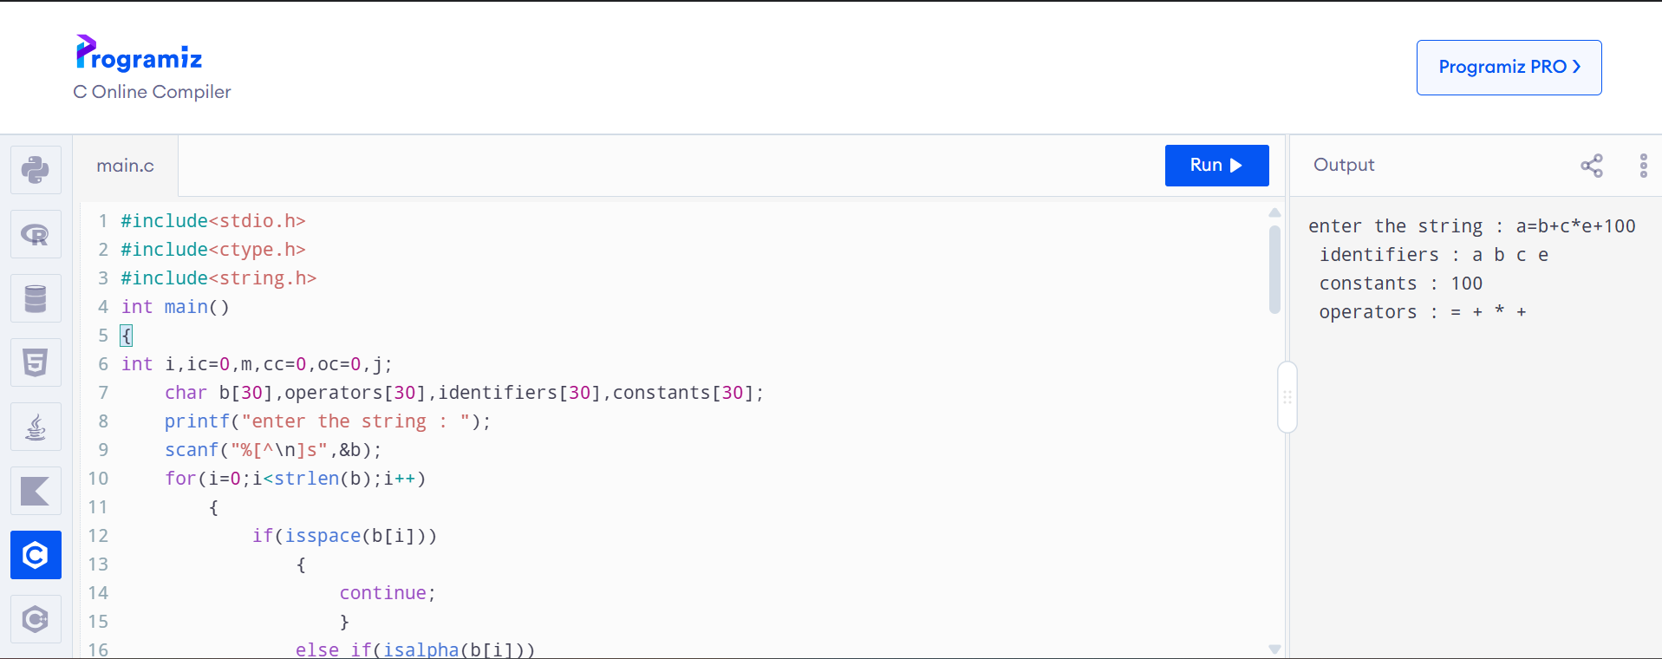
RESULT:Successfully Developed a lexical Analyzer to identify identifiers, constants, operators using C program.

